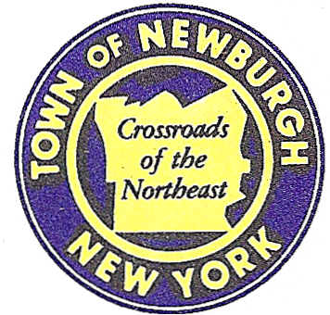

TOWN OF NEWBURGH
_______Crossroads of the Northeast __________________________
OLD TOWN HALL
308 GARDNERTOWN ROAD NEWBURGH, NEW YORK 12550

PLANNING BOARD
JOHN P. EWASUTYN, CHAIRMAN
TELEPHONE 845-564-7804
FAX 845-564-7802
E-MAIL: planningboard@townofnewburgh.org

PLANNING BOARD AGENDA

February 6th, 2020

*PLEASE NOTE: The Planning Board Meeting will start at 7:00 P.M. and all Applicants/Representatives
are to be present at that time. The Meeting will be held in the Meeting Room of Town Hall,
located at 1496 Route 300, Newburgh NY.*

- BJ’s Wholesale Club- Newburgh (19-07) AMENDED SITE PLAN
NYS Route 17K & Auto Park Place CHANGE IN ACCESS
Section 97, Block 2, Lot 44,46.2 & 45
Zone: IB
Rep: Maser Consulting, P.A.
555 Hudson Valley Ave. Suite 101
New Windsor, NY 12553

- Darrigo Solar (19-24) SOLAR FARM
86 Lakeside Road SITE PLAN
Section 86, Block 1, Lot 96
Zone: R-1
Rep: Jeffrey Lease
597 Grand Ave.
Newburgh, NY 12550

- Ready Coffee (19-26) AMENDED SITE PLAN
Gardnertown Road- Northwest corner
Section 76, Block 4, Lot 3
Zone: B
Rep: Lothrop Associates, LLP
33 Westchester Avenue
White Plains, NY 10604

*WORK SESSION*
Project Readiness Discussion scheduled for 5:30 p.m. in the Meeting Room of
Town Hall on Thursday, February 6th, 2020.*

4. Donnelly-Leslie Road Subdivision (20-01) INITIAL APPEARANCE
67 Leslie Road 3 LOT SUBDIVISION
Section 26, Block 6 Lot 25
Zone: R-2
Rep: Engineering & Surveying Properties, P.C.
71 Clinton St.
Montgomery, NY 12549

5. Young Subdivision (20-02) INITIAL APPEARANCE
50 Millhouse Road 4 LOT SUBDIVISION
Section 8, Block 1, Lot 52.2
Zone: AR
Rep: Engineering & Surveying Properties, P.C.
71 Clinton St.
Montgomery, NY 12549

PLANNING BOARD BUSINESS
WORK SESSION

*WORK SESSION*
Project Readiness Discussion scheduled for 5:30 p.m. in the Meeting Room of
Town Hall on Thursday, February 6th, 2020.*

